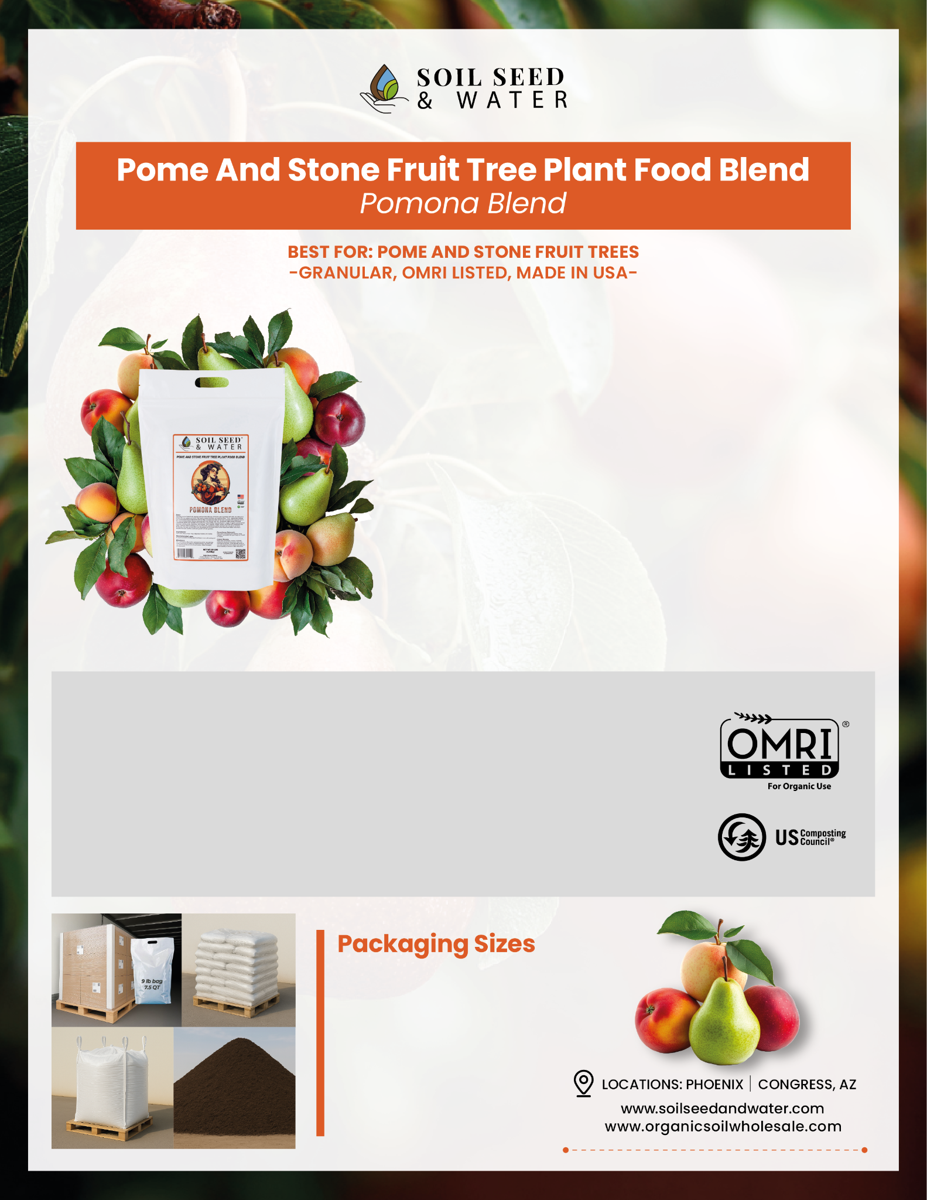

Key Benefits
Specially formulated for pome and stone fruit trees to promote vigorous growth and abundant yields.
Enriches soil with essential nutrients and beneficial microbes for healthier roots and disease resistance.
Improves soil structure, aeration, and water retention for optimal fruit tree development.
Supports robust photosynthesis and nutrient uptake with magnesium and zinc for stronger, more productive trees.
Ingredients & Purpose
WORM CASTINGS: Enhance soil structure, water retention, and aeration; provide slow-release nutrients (NPK); introduce beneficial microorganisms for improved soil health and disease suppression.
MAGNESIUM SULFATE: Supplies essential magnesium and sulfur for chlorophyll production, photosynthesis, and protein synthesis, supporting vigorous plant growth.
ZINC SULFATE: Provides zinc to promote enzyme activation, protein synthesis, robust root and shoot development, and increased flowering and fruiting.
ORGANIC DAIRY COMPOST: Improves soil structure, enriches with nutrients, boosts microbial activity, and enhances water retention for sustainable, healthy plant growth.
Application
FOR NEW PLANTINGS: Mix 1 part Pomona Blend with 4 parts existing soil.
FOR ESTABLISHED TREES: Top-dress with a 1/2" layer and gently work into the soil surface. Water thoroughly after application.
9 LB
1 CF
2.2 CY TOTE
BULK (TONS/CY)
TRUCKLOAD BULK
(22-24 TONS)

